1. Data Acquisition and Pre-processing
- Read the provided `.csv` dataset containing Riya’s 15-day store activity.
- Perform data cleaning: Check for missing or inconsistent entries.
- Apply pre-processing using Pandas and NumPy.

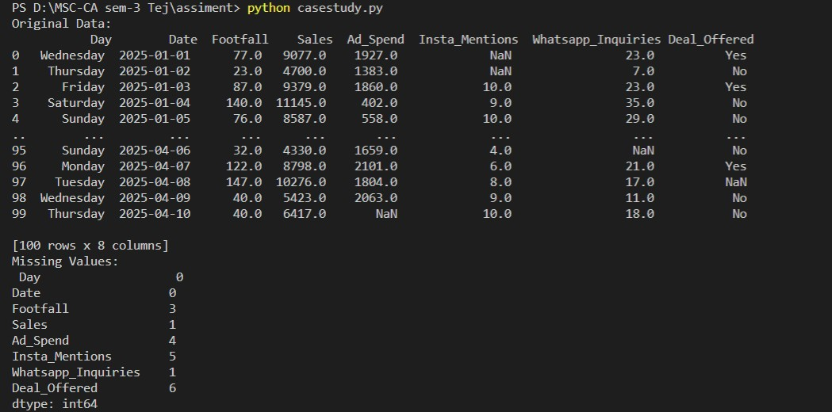

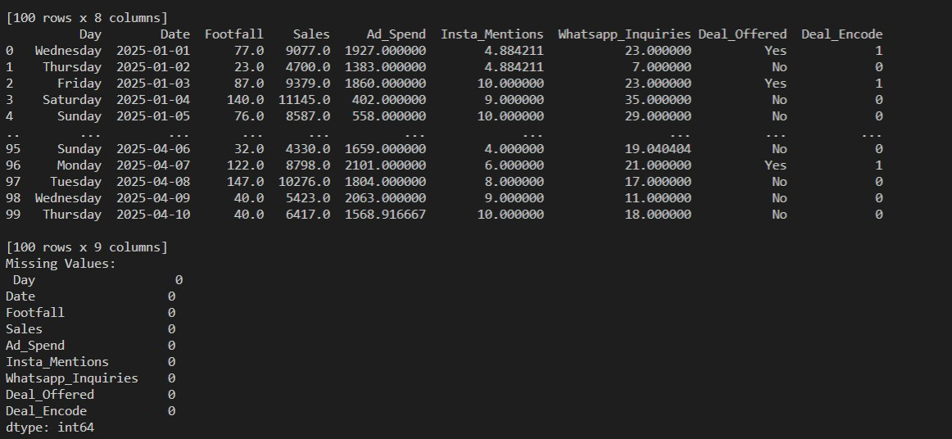

2. Data Transformation
- Normalize numerical columns (like sales, ad spend, inquiries) using Min-Max or Z-score normalization.
- Convert categorical data (like Day or Deal Offered) into numerical format for modeling.

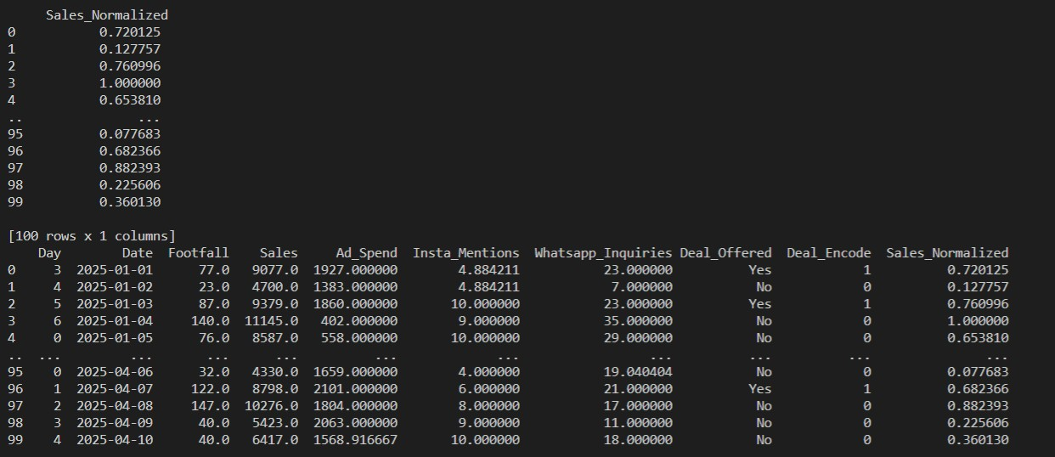

3. Exploratory Data Analysis (EDA)
- Plot summary statistics: mean, median, mode, etc.
- Identify any outliers in the data (e.g., a sudden spike in inquiries or footfall).
- Check correlations between:
  - Influencer mentions and sales
  - Ad spend and footfall
WhatsApp inquiries and actual purchases

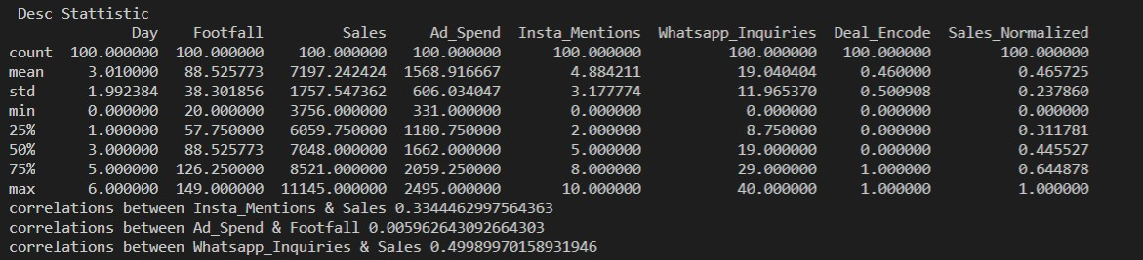
e

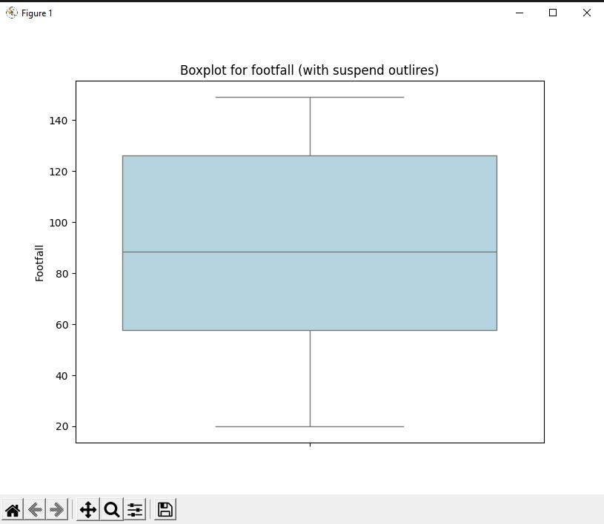
- Data Visualization –
Use Matplotlib and Seaborn to:
  - Plot footfall and sales over time
  - Visualize relationships using scatterplots or pair plots
  - Show distribution of daily footfall/sales using histograms or boxplots

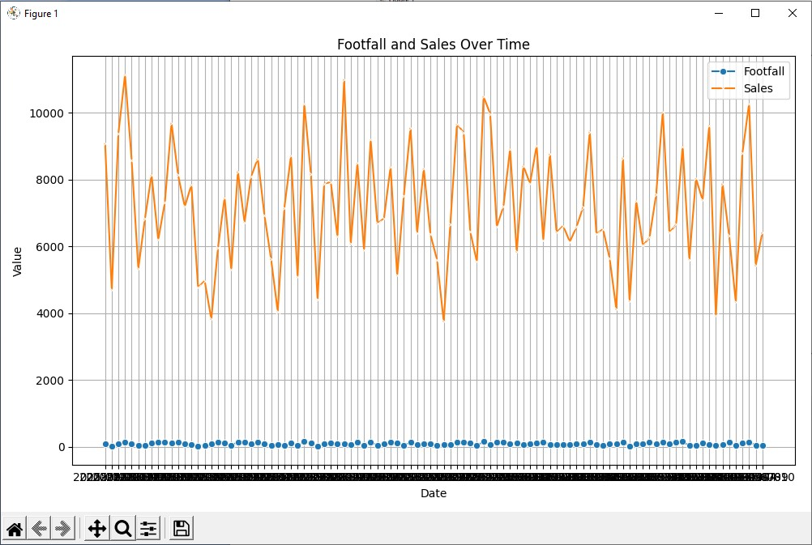

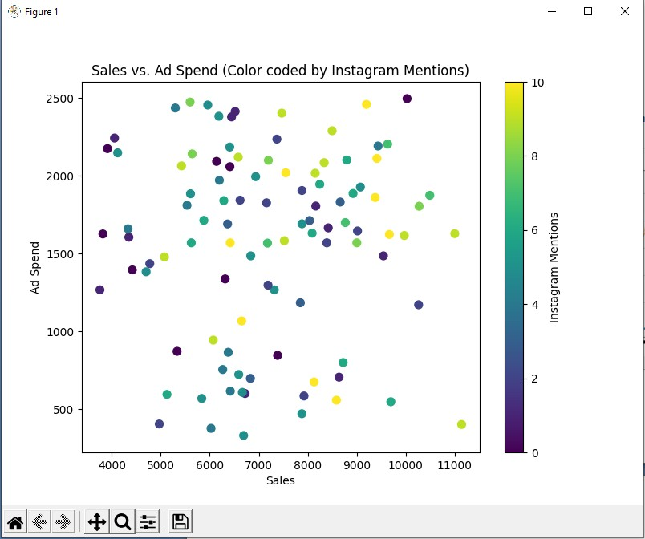

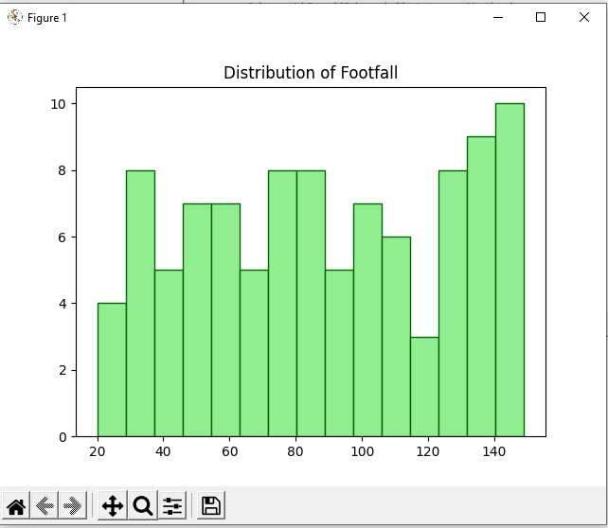

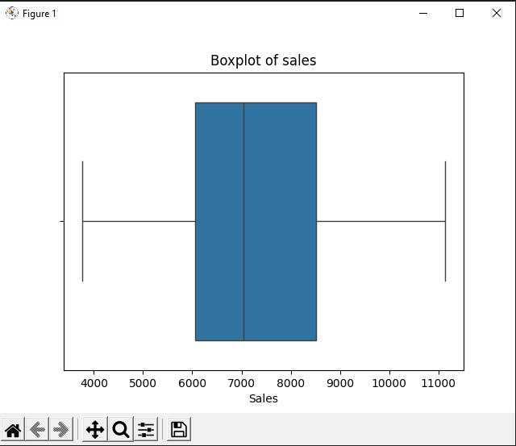

- Data Modeling and Analysis
- Build a Linear Regression model to predict sales using independent variables (ad spend, footfall, inquiries, influencer posts).
- Build a Logistic Regression model to predict the probability of ‘High Sales Day’ (1 if sales > ₹5000, 0 otherwise).
- Use summary outputs to explain what variables have the most influence.

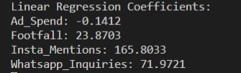

6. Bonus – Time Series Element
- Try plotting sales and footfall over days.
- Discuss whether there's a weekly pattern or trend (e.g., higher sales on weekends).

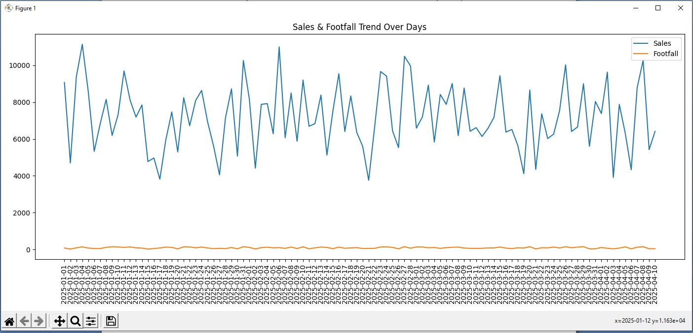

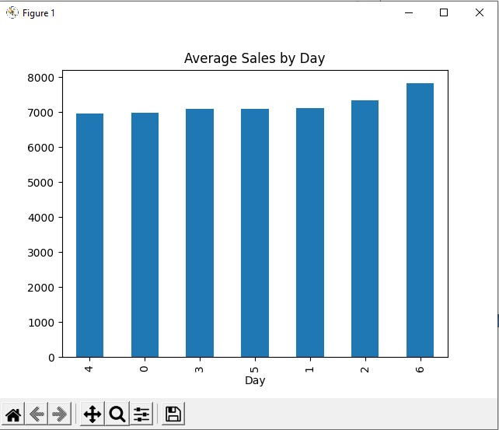

Code:-

import numpy as np import pandas as pd from sklearn.preprocessing import LabelEncoder, MinMaxScaler from sklearn.linear_model
import LinearRegression, LogisticRegression
import matplotlib.pyplot as plt
import seaborn as sns

data = pd.read_csv('threadora_boutique_data.csv') df = pd.DataFrame(data) print("Original Data:\n", df)

# missing value print("Missing Values:\n", df.isnull().sum())
df['Ad_Spend'].fillna(df['Ad_Spend'].mean(),
inplace=True) print(df)
df['Footfall'].fillna(df['Footfall'].mean(),
inplace=True) print(df)
df['Sales'].fillna(df['Sales'].mean(), inplace=True) print(df)
df['Insta_Mentions'].fillna(df['Insta_Mentions'].mean(),
inplace=True) print(df)
df['Whatsapp_Inquiries'].fillna(df['Whatsapp_Inquiries'].mean(), inplace=True) print(df)
df['Deal_Offered'].fillna(df['Deal_Offered'].mode()[0],
inplace=True) print(df)
dealoffer = LabelEncoder() df['Deal_Encode'] = dealoffer.fit_transform(df['Deal_Offered']) print(df) print("Missing Values:\n", df.isnull().sum())

# # Min-Max Normalization for
Marks scaler = MinMaxScaler() df['Sales_Normalized'] = scaler.fit_transform(df[['Sales']]) print("\nTransformed Data:\n", df[['Sales_Normalized']])
df['Day'] = df['Day'].replace({'Sunday': 0 ,'Monday': 1,'Tuesday': 2,'Wednesday': 3,'Thursday': 4,'Friday': 5,'Saturday': 6}) print(df)
print("\n Desc Stattistic") print(df.describe())
plt.figure(figsize=(16,20))
sns.boxplot(y=df['Footfall'], color='lightblue') plt.title("Boxplot for footfall (with suspend outlires)") plt.show()

Q1 = df['Footfall'].quantile(0.25)
Q3 = df['Footfall'].quantile(0.75)
IQR = Q3 - Q1

# Define outlier bounds lower_
bound = Q1 - 1.5 * IQR upper_bound = Q3 + 1.5 * IQR

# Identify outliers
outliers = df[(df['Footfall'] < lower_bound) | (df['Footfall'] > upper_bound)]

corr = df['Insta_Mentions'].corr(df['Sales']) print("correlations between Insta_Mentions & Sales",corr)
corr = df['Ad_Spend'].corr(df['Footfall']) print("correlations between Ad_Spend & Footfall",corr)
corr = df['Whatsapp_Inquiries'].corr(df['Sales']) print("correlations between Whatsapp_Inquiries & Sales",corr)

# ques 4 plt.figure(figsize=(10, 6)) sns.lineplot(x='Date', y='Footfall', data=df, label='Footfall', marker='o') sns.lineplot(x='Date', y='Sales', data=df, label='Sales', marker='x') plt.title('Footfall and Sales Over Time') plt.xlabel('Date') plt.ylabel('Value') plt.legend() plt.grid(True) plt.tight_layout() plt.show()

df = pd.DataFrame(data)
x = df['Sales'] y = df['Ad_Spend'] z = df['Insta_Mentions']
plt.figure(figsize=(8, 6)) plt.scatter(x, y, c=z, cmap='viridis', s=50) plt.xlabel("Sales") plt.ylabel("Ad Spend") plt.title("Sales vs. Ad Spend (Color coded by Instagram Mentions)") plt.colorbar(label='Instagram Mentions') plt.show()
df = pd.DataFrame(data) plt.hist(df['Footfall'], bins=15, color='lightgreen', edgecolor='darkgreen') plt.title('Distribution of Footfall') plt.show()
sns.boxplot(x=df['Sales']) plt.title('Boxplot of sales') plt.show()

# 5
# Build a Linear Regression model to predict sales using independent variables (ad # spend, footfall, inquiries, influencer posts)
X = df[['Ad_Spend', 'Footfall', 'Insta_Mentions', 'Whatsapp_Inquiries']] y = df['Sales']
model = LinearRegression() model.fit(X, y)
print("Linear Regression Coefficients:") for feature, coef in zip(X.columns, model.coef_):
print(f"{feature}: {coef:.4f}")

# # - Build a Logistic Regression model to predict the probability of ‘High Sales Day’ (1 if
# sales > ₹5000, 0 otherwise).
df['High_Sales_Day'] = (df['Sales'] > 0.5).astype(int)
X = df[['Footfall', 'Ad_Spend', 'Whatsapp_Inquiries', 'Insta_Mentions']] y = df['High_Sales_Day']
log_model = LogisticRegression() log_model.fit(X, y)
print("Logistic Regression Coefficients:") for feature, coef in zip(X.columns, log_model.coef_[0]):
print(f"{feature}: {coef:.4f}")
# 6
# Try plotting sales and footfall over days.
plt.figure(figsize=(14,6)) plt.plot(df['Date'], df['Sales'], label='Sales') plt.plot(df['Date'], df['Footfall'], label='Footfall') plt.xticks(rotation=90) plt.title('Sales & Footfall Trend Over Days') plt.legend() plt.tight_layout() plt.show()

# Discuss whether there's a weekly pattern or trend (e.g., higher sales on weekends)
weekly_avg = df.groupby('Day')['Sales'].mean().sort_values() weekly_avg.plot(kind='bar', title="Average Sales by Day") plt.show()

Ques 2. Visualizing Cricketer Performance:

- Load a dataset containing cricket players&#39; performance (e.g., runs scored, wickets taken,
strike rate).
- Create a scatter plot to visualize the relationship between runs scored and strike rate.
- Use a bar chart to compare the total runs scored by top 5 players.
- Plot the progression of a player&#39;s runs across different matches using a line chart.

Code :-

import pandas as pd
import matplotlib.pyplot as plt
import seaborn as sns
df = pd.read_csv("cricketer_performance.csv")
print("Data Loaded Successfully!")
print(df.head())

plt.figure(figsize=(8, 5))
sns.scatterplot(x="Runs", y="StrikeRate", data=df, hue="Player", s=80)
plt.title("Relationship Between Runs Scored and Strike Rate", fontsize=14)
plt.xlabel("Runs Scored")
plt.ylabel("Strike Rate")
plt.grid(True)
plt.tight_layout()
plt.show()

total_runs = df.groupby("Player")["Runs"].sum().sort_values(ascending=False).reset_index()

plt.figure(figsize=(8, 5))
sns.barplot(x="Player", y="Runs", data=total_runs, palette="Blues_d")
plt.title("Total Runs Scored by Top 5 Players", fontsize=14)
plt.xlabel("Player")
plt.ylabel("Total Runs")
plt.xticks(rotation=45)
plt.tight_layout()
plt.show()

player_name = "Virat Kohli"
player_data = df[df["Player"] == player_name]

plt.figure(figsize=(8, 5))
plt.plot(player_data["Match"], player_data["Runs"], marker="o", color="green", linewidth=2)
plt.title(f"Run Progression of {player_name} Across Matches", fontsize=14)
plt.xlabel("Match Number")
plt.ylabel("Runs Scored")
plt.grid(True)
plt.tight_layout()
plt.show()
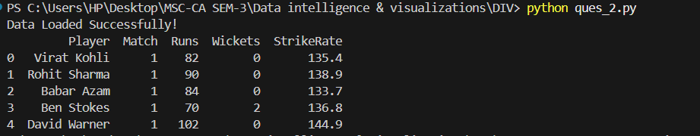

-Create a scatter plot to visualize the relationship between runs scored and strike rate.

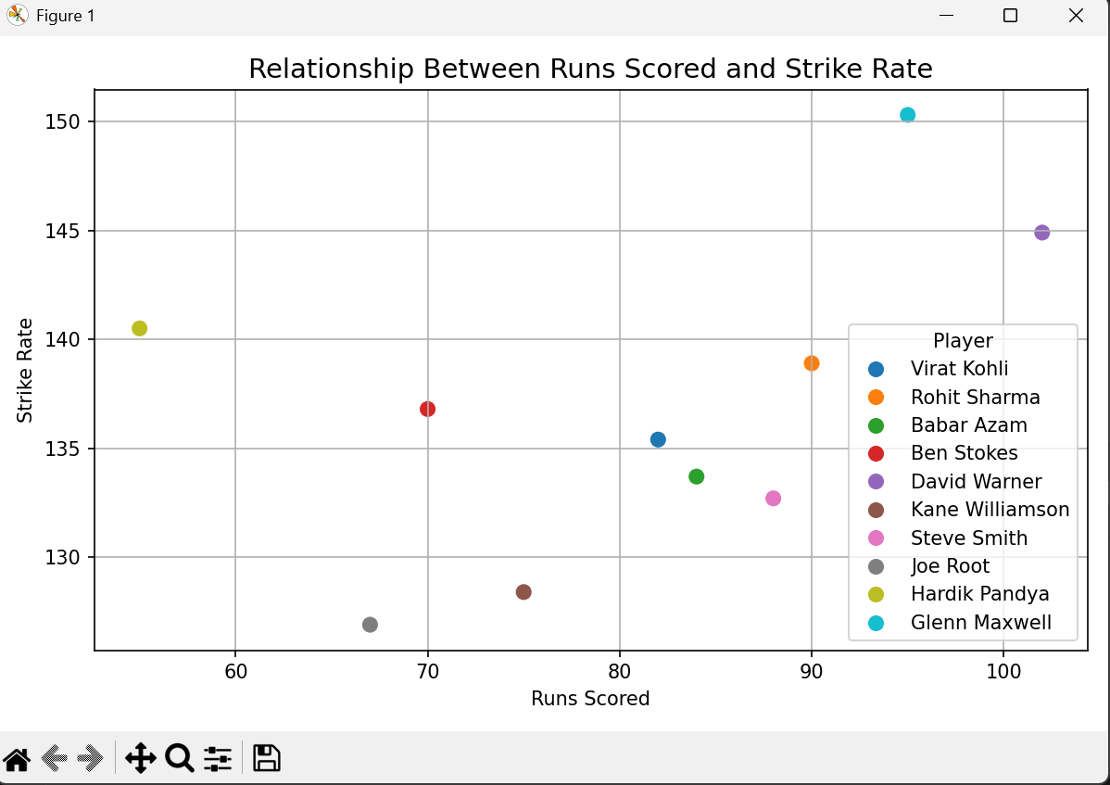

-Use a bar chart to compare the total runs scored by top 5 players.

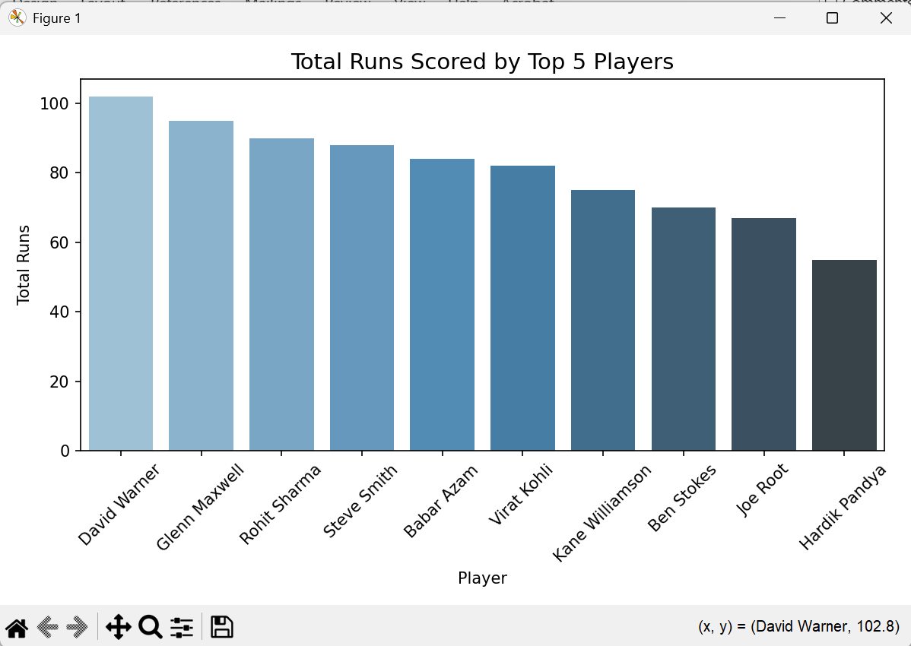

-Plot the progression of a player&#39;s runs across different matches using a line chart.

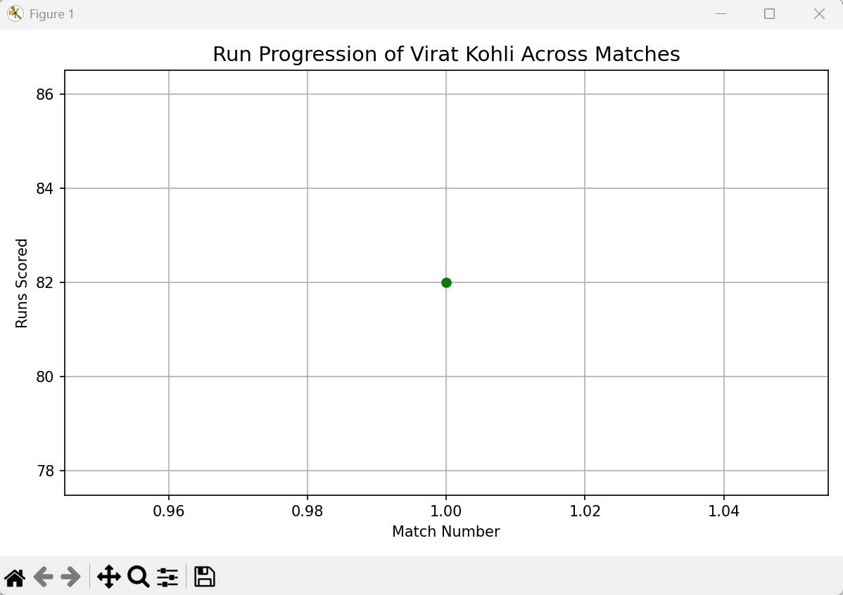

Ques 3. Tennis Match Analysis:
- Load a dataset of tennis matches and player performance (e.g., aces, double faults, win
percentage).
- Create a bar chart comparing the number of aces and double faults for top 5 players.
- Plot a line chart to show the win percentage trend of a player over a season.
- Use Seaborn’s pairplot() function to explore the relationship between different
performance metrics.

Code:-
import pandas as pd
import numpy as np
import matplotlib.pyplot as plt
import seaborn as sns

df = pd.read_csv("tennis_data.csv")

print("Dataset Loaded Successfully!")
print(df.head())

avg_stats = df.groupby('Player')[['Aces', 'DoubleFaults']].mean().reset_index()

plt.figure(figsize=(8, 5))
x = np.arange(len(avg_stats['Player']))
width = 0.35
plt.bar(x - width/2, avg_stats['Aces'], width, label='Aces', color='skyblue')
plt.bar(x + width/2, avg_stats['DoubleFaults'], width, label='Double Faults', color='salmon')

plt.xticks(x, avg_stats['Player'], rotation=45, ha='right')
plt.xlabel('Player')
plt.ylabel('Average Count per Match')
plt.title('Comparison of Aces and Double Faults (Top 5 Players)')
plt.legend()
plt.tight_layout()
plt.show()

player_name = 'Roger Federer'
player_data = df[df['Player'] == player_name]

plt.figure(figsize=(8, 5))
plt.plot(player_data['Match'], player_data['WinPercentage'], marker='o', color='green')
plt.title(f'Win Percentage Trend - {player_name}')
plt.xlabel('Match Number')
plt.ylabel('Win Percentage')
plt.ylim(50, 105)
plt.grid(True)
plt.show()

num_cols = ['Aces', 'DoubleFaults', 'FirstServe%', 'BreakPointsSaved%', 'WinPercentage']
existing_cols = [col for col in num_cols if col in df.columns]

sns.pairplot(df[existing_cols], diag_kind='kde', plot_kws={'alpha': 0.6})
plt.suptitle('Performance Metrics Relationship', y=1.02)
plt.show()

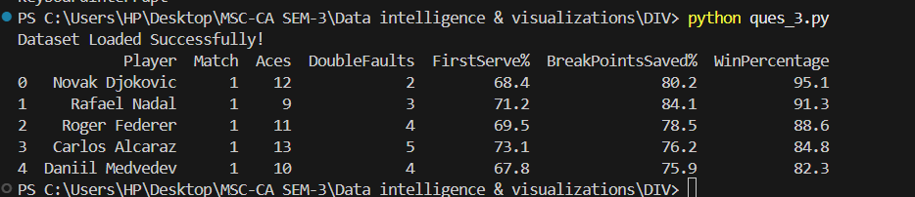

- Create a bar chart comparing the number of aces and double faults for top 5 players.

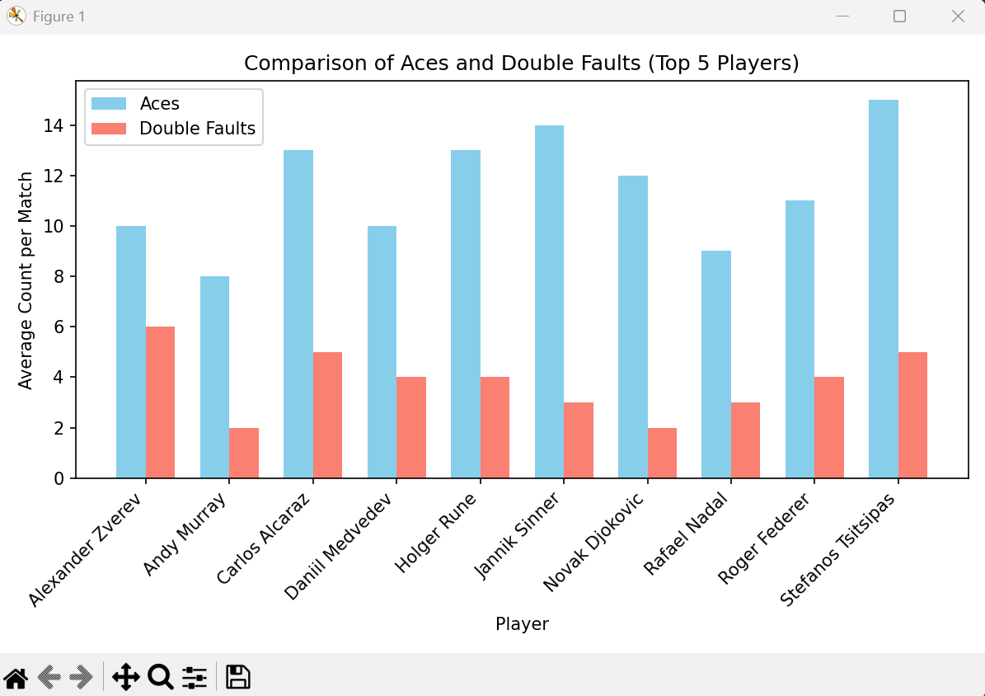

- Plot a line chart to show the win percentage trend of a player over a season.

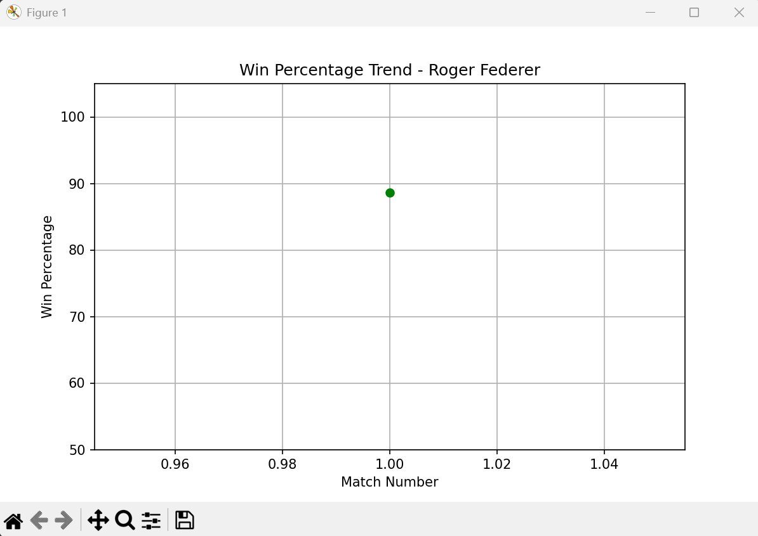

- Use Seaborn’s pairplot() function to explore the relationship between different
performance metrics.

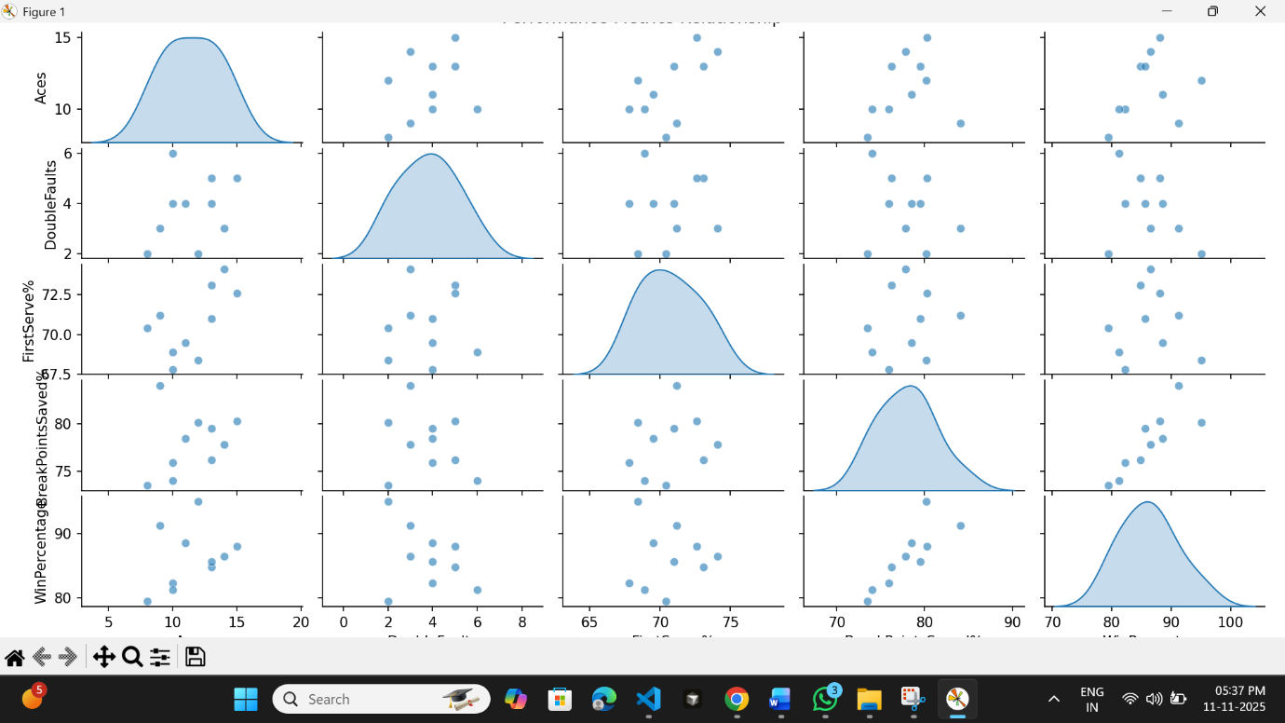

Ques 4.Patient Health Records Visualization:
- Given a dataset of patient health records (e.g., age, blood pressure, cholesterol levels):
- Create a box plot to identify outliers in blood pressure readings.
- Use a scatter plot to visualize the relationship between age and cholesterol levels.
- Plot the distribution of patients&#39; ages using a histogram.

Code:-

import pandas as pd
import matplotlib.pyplot as plt
import seaborn as sns

df = pd.read_csv("patient_health.csv")

print("Dataset Loaded Successfully!")
print(df.head())

plt.figure(figsize=(6, 5))
sns.boxplot(y=df["BloodPressure"], color="skyblue")
plt.title("Box Plot of Blood Pressure (Outlier Detection)")
plt.ylabel("Blood Pressure (mm Hg)")
plt.show()

plt.figure(figsize=(7, 5))
sns.scatterplot(x="Age", y="Cholesterol", data=df, color="green", s=80)
plt.title("Relationship between Age and Cholesterol Level")
plt.xlabel("Age (years)")
plt.ylabel("Cholesterol (mg/dL)")
plt.grid(True)
plt.show()

plt.figure(figsize=(7, 5))
plt.hist(df["Age"], bins=8, color="salmon", edgecolor="black")
plt.title("Distribution of Patient Ages")
plt.xlabel("Age (years)")
plt.ylabel("Number of Patients")
plt.grid(axis='y')
plt.show()

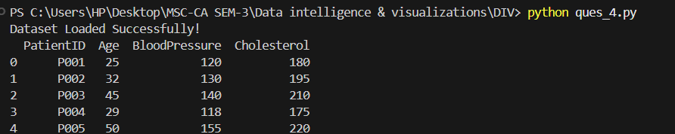

- Create a box plot to identify outliers in blood pressure readings.

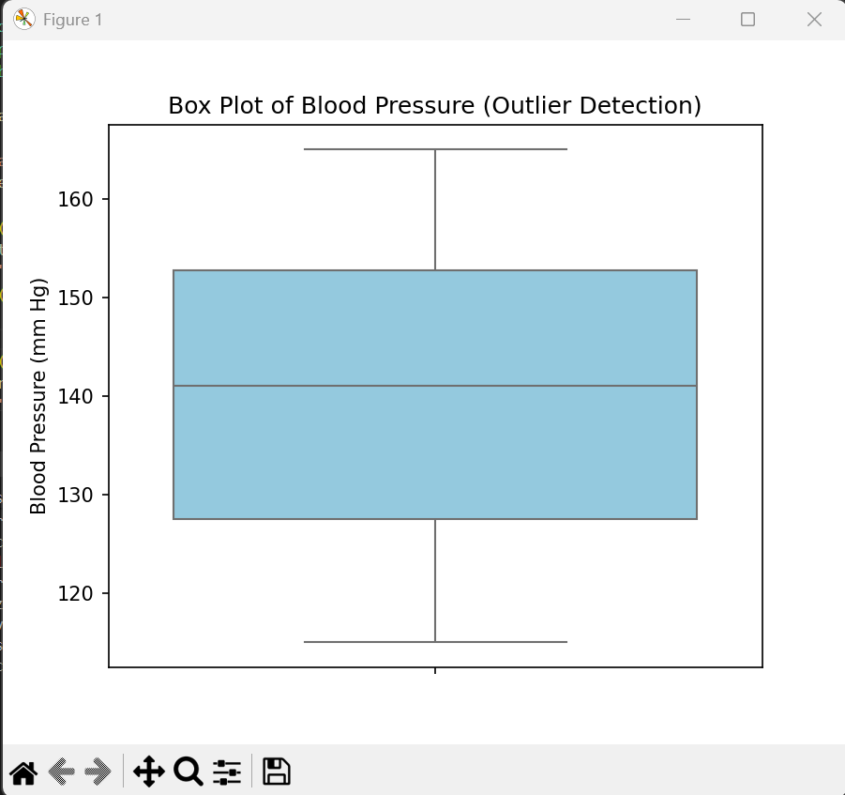

- Use a scatter plot to visualize the relationship between age and cholesterol levels.

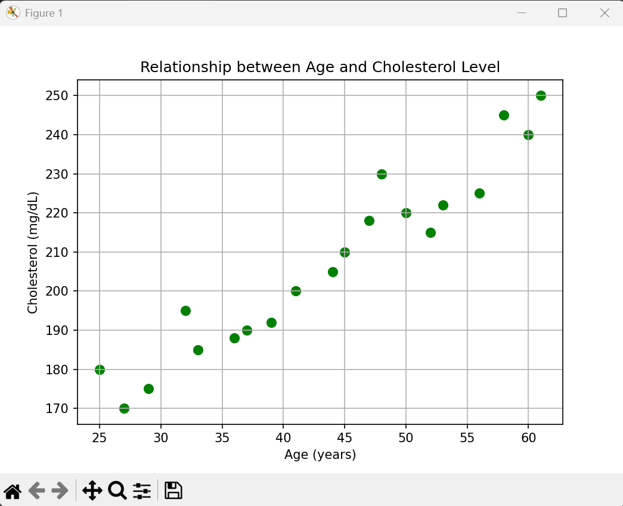

- Plot the distribution of patients&#39; ages using a histogram.

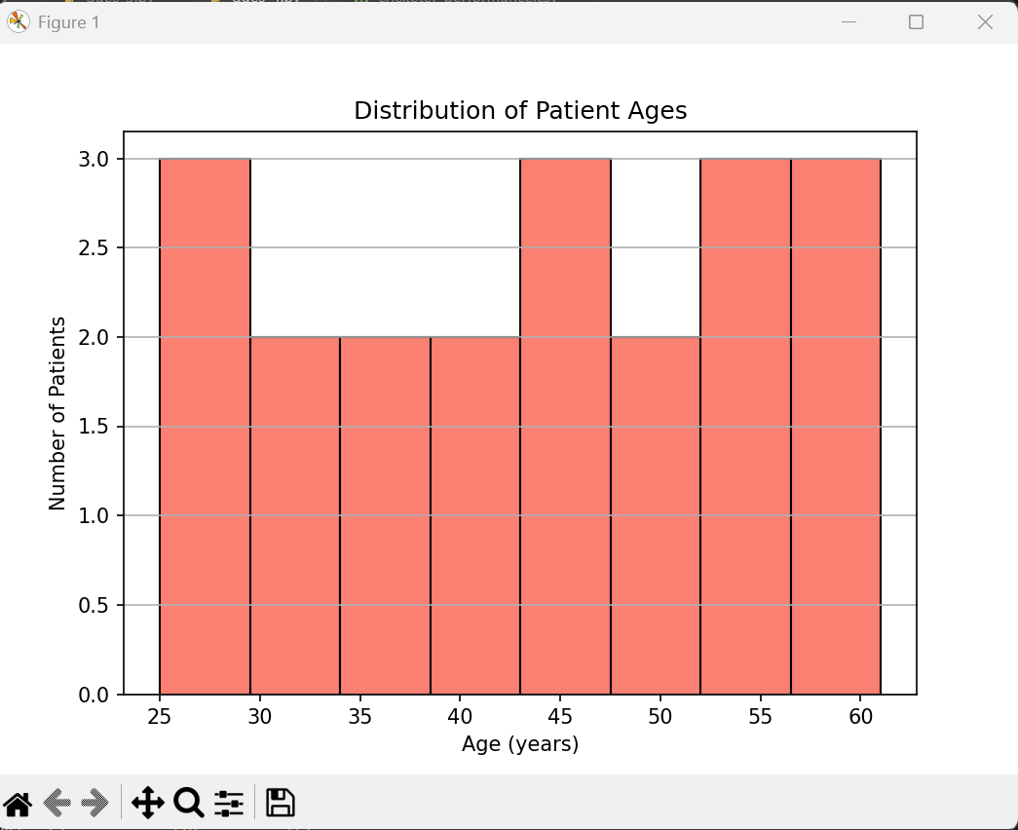

Ques 5. Stock Market Analysis:
- Load stock price data for multiple companies (e.g., open, close, high, low prices).
- Create a line chart to visualize the stock price movement of a company over time.
- Use a candlestick chart to show daily price fluctuations.
- Plot a correlation heatmap to examine the relationship between stock prices of different
companies.

Code:-

import pandas as pd
import matplotlib.pyplot as plt
import seaborn as sns
import mplfinance as mpf #pip install pandas matplotlib seaborn mplfinance

df = pd.read_csv("stock_data.csv")
df['Date'] = pd.to_datetime(df['Date'])
print("Data Loaded Successfully!")
print(df.head())

company = "Apple"
company_data = df[df['Company'] == company]

plt.figure(figsize=(8, 5))
plt.plot(company_data['Date'], company_data['Close'], marker='o', color='green')
plt.title(f"{company} Stock Price Movement Over Time")
plt.xlabel("Date")
plt.ylabel("Closing Price ($)")
plt.grid(True)
plt.tight_layout()
plt.show()

candlestick_data = company_data.set_index('Date')[['Open', 'High', 'Low', 'Close']]
mpf.plot(candlestick_data, type='candle', style='yahoo', title=f"{company} Daily Candlestick Chart")

pivot_df = df.pivot(index='Date', columns='Company', values='Close')

plt.figure(figsize=(7, 5))
sns.heatmap(pivot_df.corr(), annot=True, cmap="coolwarm", fmt=".2f")
plt.title("Correlation Between Companies' Closing Prices")
plt.tight_layout()
plt.show()
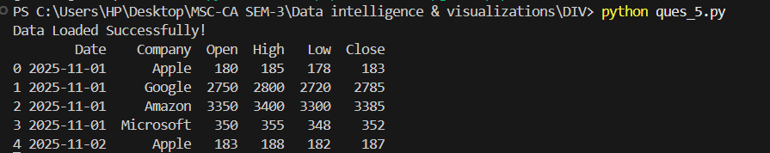

- Create a line chart to visualize the stock price movement of a company over time.

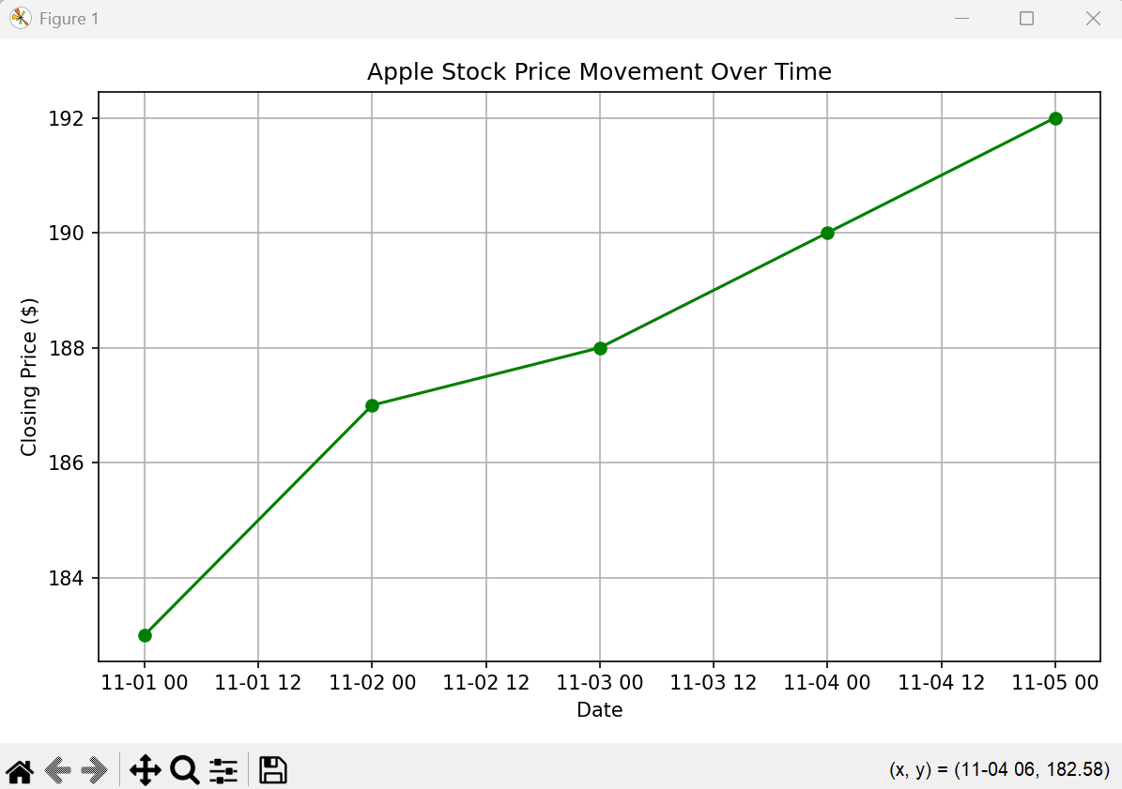

- Use a candlestick chart to show daily price fluctuations.

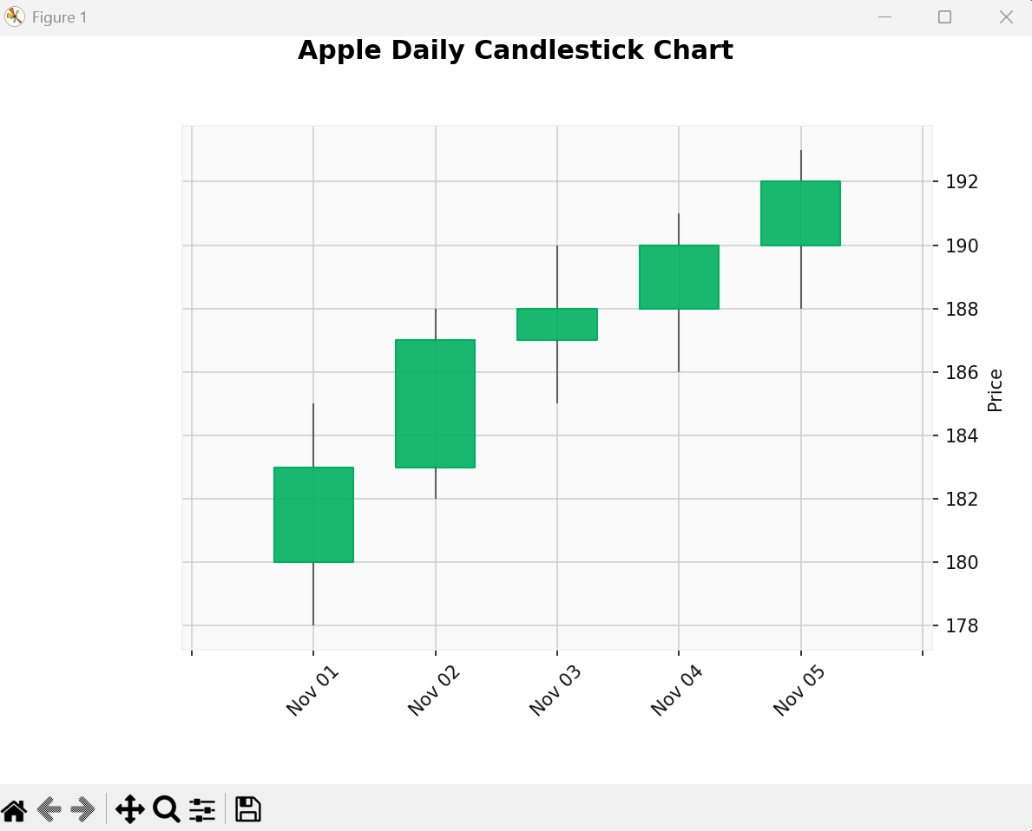

- Plot a correlation heatmap to examine the relationship between stock prices of different
companies.

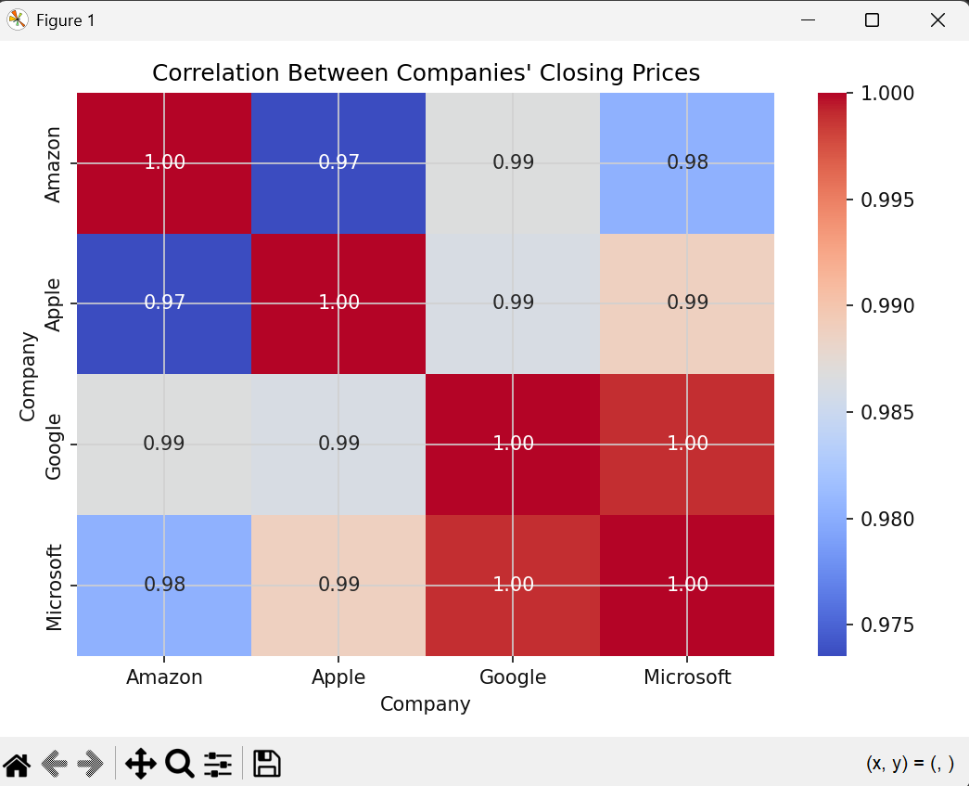

6. Student Performance Analysis:
- Load a dataset containing student performance (e.g., exam scores, attendance, study hours).
- Create a bar chart to compare the average exam scores for students across different study
hours.
- Use a box plot to visualize the distribution of exam scores across different grades.
- Plot a scatter plot to show the relationship between study hours and exam scores.

Code:-

import pandas as pd
import matplotlib.pyplot as plt
import seaborn as sns

df = pd.read_csv("student_performance.csv")
print("Data Loaded Successfully!")
print(df.head())

avg_scores = df.groupby("StudyHours")["ExamScore"].mean().reset_index()

plt.figure(figsize=(8, 5))
sns.barplot(x="StudyHours", y="ExamScore", data=avg_scores, palette="Blues_d")
plt.title("Average Exam Scores by Study Hours", fontsize=14)
plt.xlabel("Study Hours per Day")
plt.ylabel("Average Exam Score")
plt.grid(axis="y", linestyle="--", alpha=0.7)
plt.tight_layout()
plt.show()

plt.figure(figsize=(7, 5))
sns.boxplot(x="Grade", y="ExamScore", data=df, palette="Set2")
plt.title("Distribution of Exam Scores by Grade", fontsize=14)
plt.xlabel("Grade")
plt.ylabel("Exam Score")
plt.tight_layout()
plt.show()

plt.figure(figsize=(7, 5))
sns.scatterplot(x="StudyHours", y="ExamScore", data=df, hue="Grade", s=80, palette="coolwarm")
plt.title("Relationship Between Study Hours and Exam Scores", fontsize=14)
plt.xlabel("Study Hours per Day")
plt.ylabel("Exam Score")
plt.grid(True)
plt.tight_layout()
plt.show()

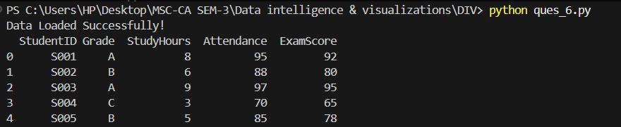

- Create a bar chart to compare the average exam scores for students across different study
hours.
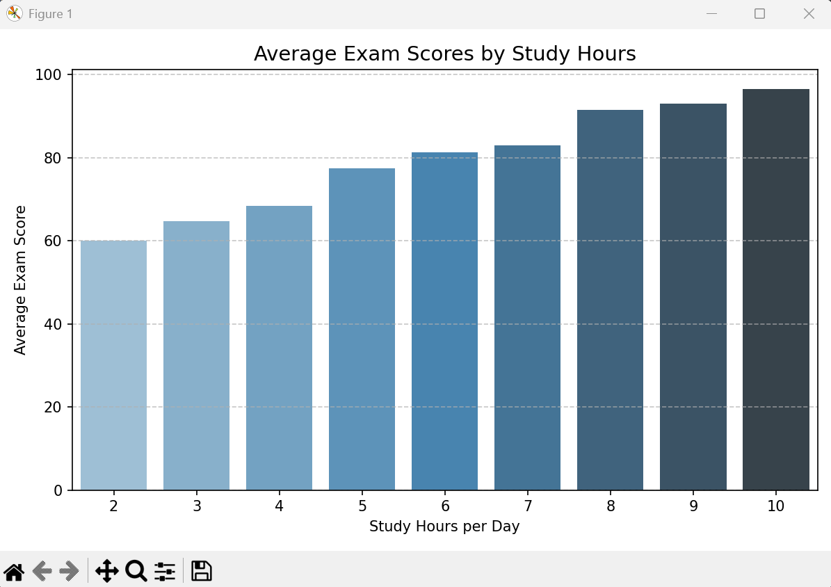

- Use a box plot to visualize the distribution of exam scores across different grades.

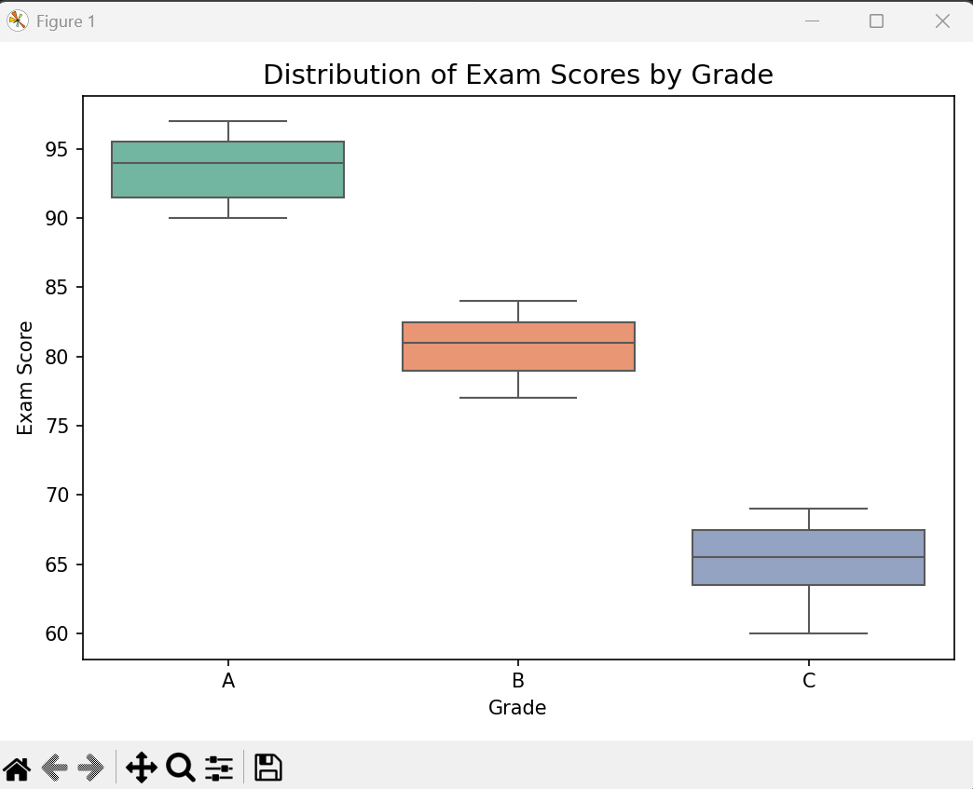

- Plot a scatter plot to show the relationship between study hours and exam scores.

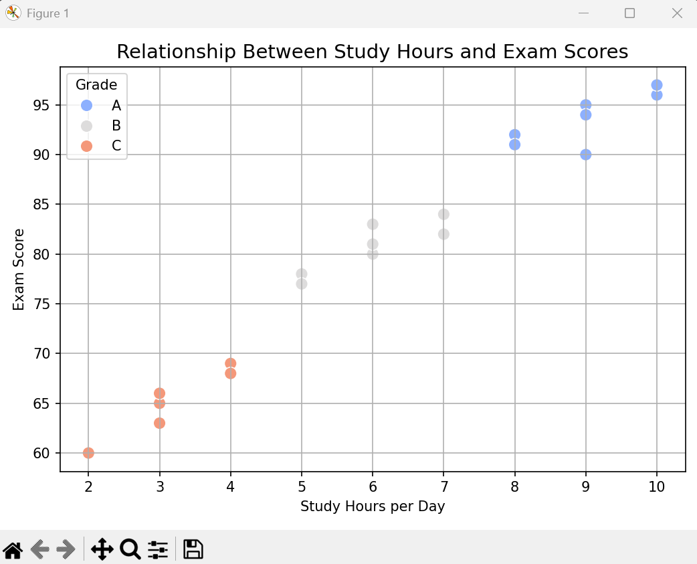

7.University Admissions Data:
- Use a dataset containing university admissions data (e.g., GPA, SAT scores, admission
status).
- Create a violin plot to show the distribution of SAT scores for admitted and rejected
students.
- Use a histogram to visualize the distribution of GPA scores.
- Plot a scatter plot to explore the relationship between GPA and SAT scores for admitted
students.

Code:-
import pandas as pd
import seaborn as sns
import matplotlib.pyplot as plt

df = pd.read_csv("university_admissions.csv")
print(" Data Loaded Successfully!")
print(df.head())

plt.figure(figsize=(8, 5))
sns.violinplot(x="AdmissionStatus", y="SAT", data=df, palette="Set2")
plt.title("Distribution of SAT Scores by Admission Status", fontsize=14)
plt.xlabel("Admission Status")
plt.ylabel("SAT Score")
plt.tight_layout()
plt.show()

plt.figure(figsize=(8, 5))
plt.hist(df["GPA"], bins=8, color="skyblue", edgecolor="black")
plt.title("Distribution of GPA Scores", fontsize=14)
plt.xlabel("GPA")
plt.ylabel("Number of Students")
plt.grid(axis='y', linestyle='--', alpha=0.7)
plt.tight_layout()
plt.show()

admitted_df = df[df["AdmissionStatus"] == "Admitted"]

plt.figure(figsize=(8, 5))
sns.scatterplot(x="GPA", y="SAT", data=admitted_df, color="green", s=80)
plt.title("GPA vs SAT Scores (Admitted Students)", fontsize=14)
plt.xlabel("GPA")
plt.ylabel("SAT Score")
plt.grid(True)
plt.tight_layout()
plt.show()

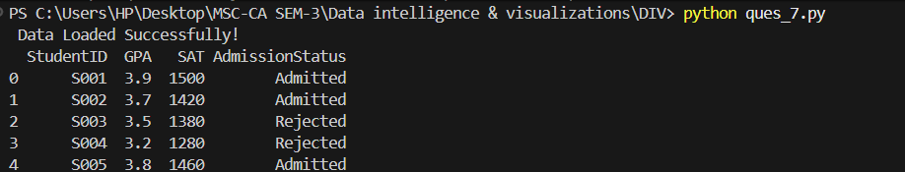

- Create a violin plot to show the distribution of SAT scores for admitted and rejected
students.

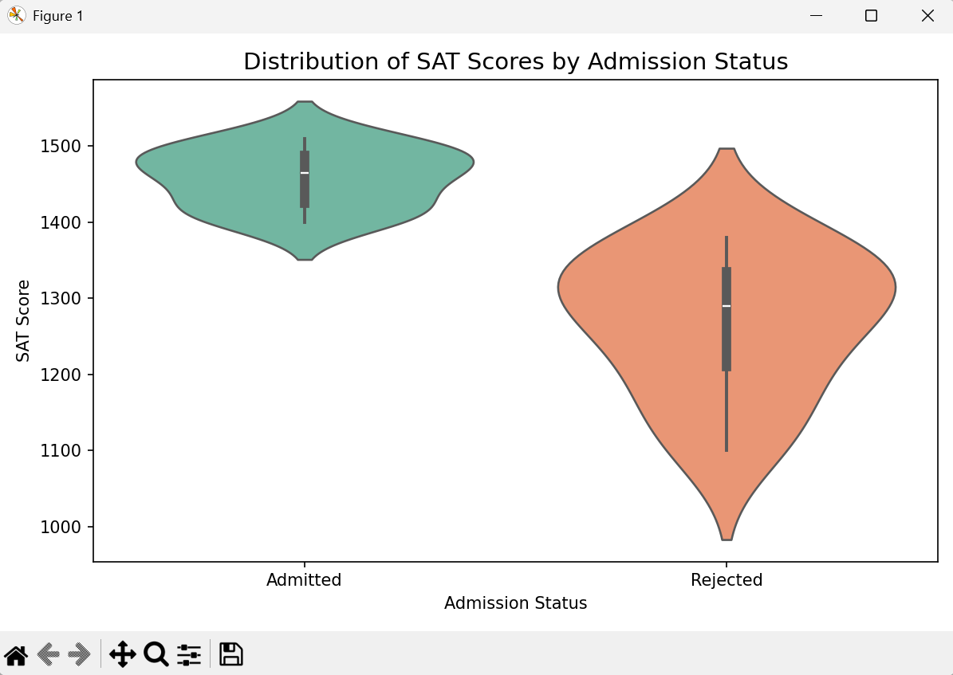

- Use a histogram to visualize the distribution of GPA scores.

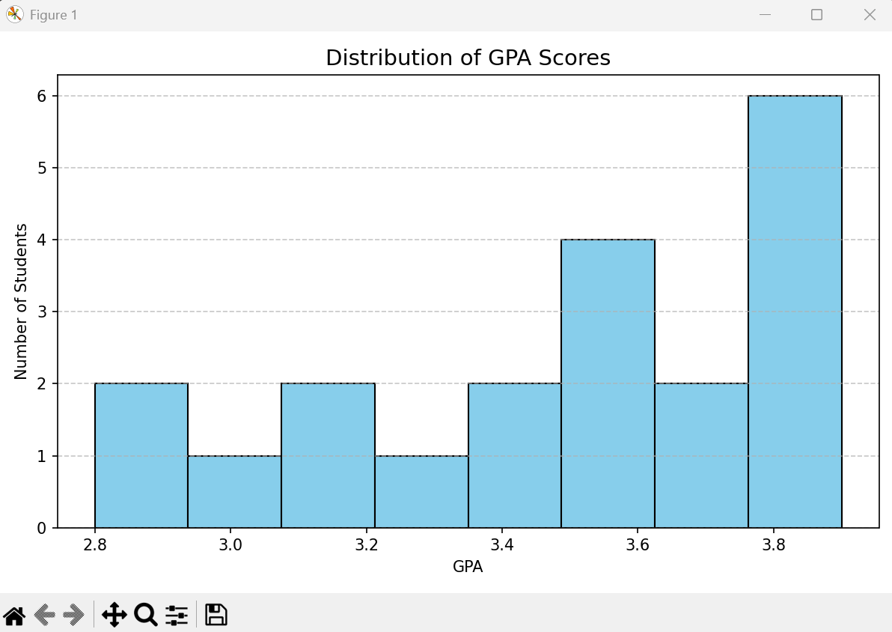

- Plot a scatter plot to explore the relationship between GPA and SAT scores for admitted
students.

